AN ANALYSIS OF SERVICE QUALITY IN MARUTI SUZUKI SERVICES USING THE SERVQUAL MODEL

Abstract This research paper evaluates the service quality of Maruti Suzuki’s service network using the SERVQUAL model. The study aims to measure the gaps between customer expectations and perceptions across five service quality dimensions: tangibles, reliability, responsiveness, assurance, and empathy. By leveraging data collected through structured questionnaires, the findings highlight key drivers of customer satisfaction and suggest managerial implications for enhancing service delivery.

- Introduction
Maruti Suzuki, established in 1981 and majority-owned by Suzuki Motor Corporation, stands as a hallmark of excellence in the Indian automotive industry. With a market share exceeding 50%, the company has become synonymous with reliability, affordability, and innovation. Its product portfolio caters to a diverse audience, ranging from entry-level hatchbacks to premium SUVs. However, beyond its product range, Maruti Suzuki's robust service network has been pivotal in sustaining its market dominance.
Launched in 1982, the service network encompasses over 3,500 centers across India, offering comprehensive maintenance, repair, and accessory services. This extensive infrastructure ensures that Maruti Suzuki not only attracts new customers but also retains existing ones by providing reliable after-sales support.
The service network contributes significantly to the company’s revenue, accounting for approximately 12% of total sales. Customer loyalty, with a return rate exceeding 70%, underscores the importance of service quality in the company's strategy.
This study employs the SERVQUAL model to dissect and evaluate Maruti Suzuki's service delivery, aiming to identify critical areas for improvement and sustain its legacy of customer satisfaction.

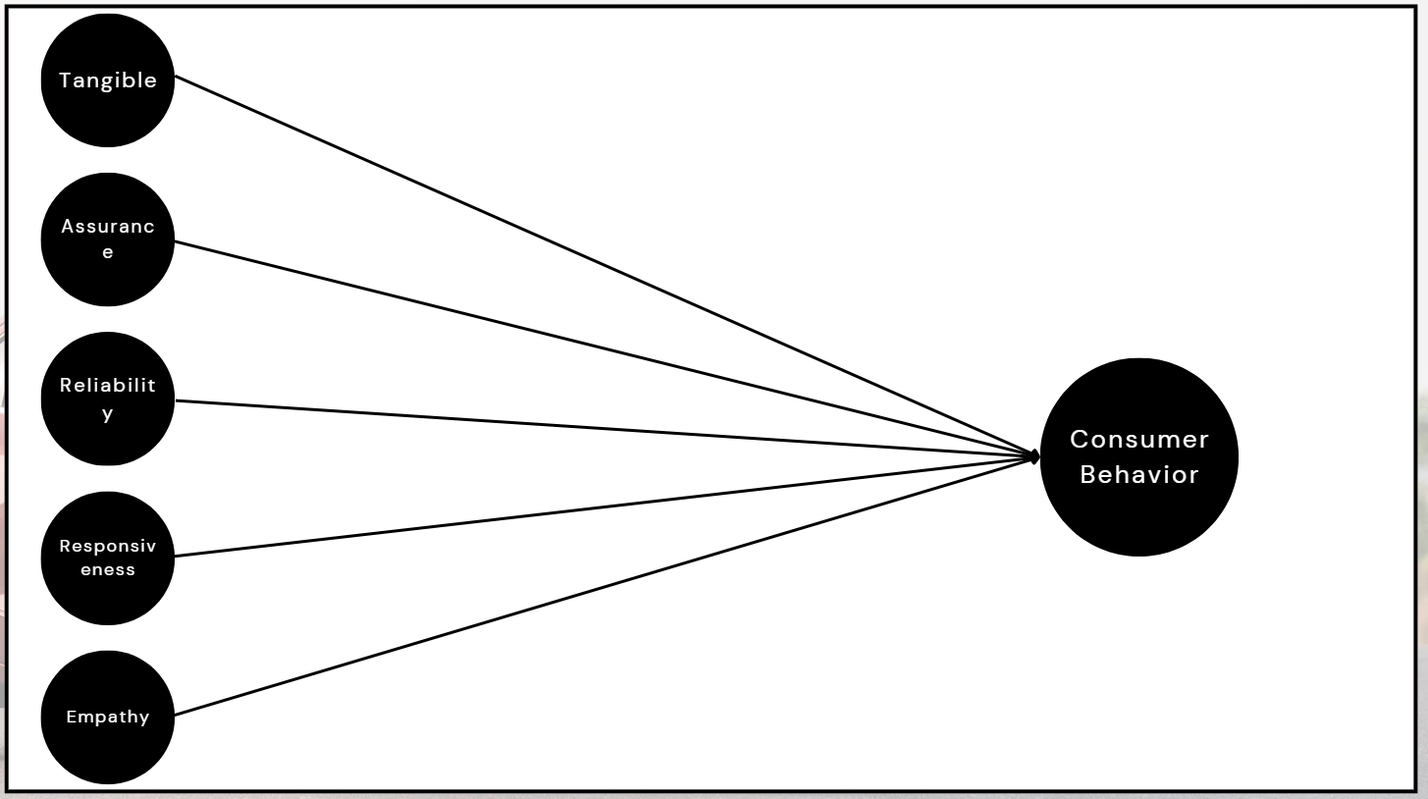
2. Literature Review
The SERVQUAL model, introduced by Parasuraman, Zeithaml, and Berry (1985), has been widely acknowledged as a comprehensive framework for evaluating service quality. Its five dimensions—tangibles, reliability, responsiveness, assurance, and empathy—offer insights into the gaps between customer expectations and perceptions. This section reviews relevant studies across industries to contextualize the model’s application.
2.1 Automotive Sector The automotive industry has extensively leveraged the SERVQUAL model to address customer satisfaction and loyalty. Voss et al. (2004) identified that tangibles, including clean facilities and state-of-the-art equipment, directly influence customer perceptions of quality. Jain and Gupta (2004) emphasized the importance of reliability and responsiveness in emerging markets like India, where trust and dependability are paramount. Additionally, Thakkar et al. (2012) revealed that assurance, through skilled staff and clear communication, enhances customer confidence in automotive services.
2.2 Healthcare Sector Babakus and Mangold (1992) adapted the SERVQUAL model to measure service quality in healthcare. Their findings underscored the significance of empathy and reliability in patient satisfaction. Subsequent studies, such as those by Andaleeb (2001), reaffirmed that personalized care and consistent service delivery are critical in sectors with high emotional stakes.
2.3 Hospitality Sector The hospitality industry’s dependence on guest satisfaction has made the SERVQUAL model a valuable tool for quality assessment. Saleh and Ryan (1991) emphasized the importance of assurance and tangibles in shaping the guest experience. Additionally, studies like Kandampully and Suhartanto (2000) found that reliability and responsiveness significantly influence repeat business and positive word-of-mouth in hospitality settings.
2.4 Banking Sector In the banking sector, Bahia and Nantel (2000) demonstrated that responsiveness and assurance are pivotal for customer retention. Ladhari (2009) extended this by examining cross-cultural applications of the SERVQUAL model, emphasizing its adaptability and relevance to varied service industries.
2.5 Retail Sector Dabholkar et al. (1996) applied the SERVQUAL model to retail environments, identifying tangibles and responsiveness as key drivers of customer satisfaction. Their findings align with studies by Sirohi et al. (1998), which linked service quality to customer loyalty in retail settings.
2.6 Academic Perspectives Seth, Deshmukh, and Vrat (2005) conducted a meta-analysis of SERVQUAL applications, illustrating its versatility across industries and geographies. They advocated for sector-specific adaptations to enhance the model’s efficacy. Furthermore, Cronin and Taylor’s (1992) SERVPERF model challenged SERVQUAL by emphasizing performance over expectations, sparking significant academic debate and enriching the discourse on service quality measurement.
3. Research Objectives
- To assess the service quality of Maruti Suzuki using the SERVQUAL model.
- To identify gaps between customer expectations and perceptions.
- To determine the most critical dimensions influencing customer satisfaction.
- To provide managerial recommendations for enhancing service quality.
4. Research Methodology
The study employs the SERVQUAL model to evaluate service quality dimensions. Data was collected using structured questionnaires distributed to customers at Maruti Suzuki service centers. The questionnaire addressed customer experiences and perceptions related to tangibles, reliability, responsiveness, assurance, and empathy. Feedback was gathered through both online and offline channels to ensure broad participation. A sample size of 300 respondents was used for the analysis.
Table 1: SERVQUAL Dimensions and Definitions
Dimension | Definition
Tangibles | Physical facilities, equipment, and appearance
Reliability | Ability to perform the promised service dependably
Responsiveness | Willingness to help customers promptly
Assurance | Knowledge and courtesy of employees
Empathy | Caring and individualized attention to customers

5. Results & Discussion
The analysis revealed the following key findings:
- Reliability: With a coefficient of 0.815, reliability emerged as the most critical factor influencing customer satisfaction. Consistent and dependable service delivery significantly impacts consumer behavior.
- Responsiveness: A coefficient of 0.265 highlights the importance of timely and helpful service in enhancing customer satisfaction.
- Empathy: The least impactful dimension, with a coefficient of 0.034, indicating that personalized care plays a minor role in customer satisfaction.
- Tangibles: A coefficient of 0.112 suggests a moderate influence of physical facilities, equipment, and appearance on consumer behavior.
- Assurance: With a coefficient of 0.108, assurance—representing customer trust in the service provider’s knowledge and professionalism—also moderately impacts satisfaction.
Figure 1: Coefficients of SERVQUAL Dimensions (Graphical representation showing coefficients for reliability, responsiveness, empathy, tangibles, and assurance)
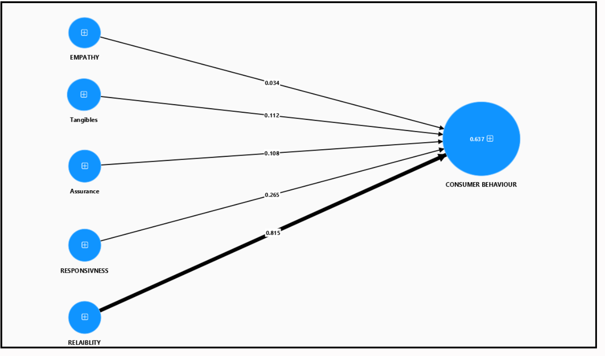
A gap analysis comparing customer expectations with perceptions highlighted areas for improvement, particularly in responsiveness and reliability.
Table 2: Gap Analysis of SERVQUAL Dimensions
Dimension | Expectations | Perceptions | Gap
Reliability | 4.8 | 4.2 | -0.6
Responsiveness | 4.7 | 4.1 | -0.6
Empathy | 4.5 | 4.3 | -0.2
Tangibles | 4.6 | 4.4 | -0.2
Assurance | 4.7 | 4.3 | -0.4

Managerial Implications
To enhance service quality and foster customer loyalty, the following recommendations are proposed:
- Enhance Reliability: Ensure consistent and dependable service delivery across all centers.
- Improve Responsiveness: Prioritize prompt and helpful customer interactions to maintain a competitive edge.
- Boost Empathy: Provide staff training to deliver personalized care and better understand customer needs.
- Upgrade Tangibles: Invest in modernizing physical facilities, tools, and center appearances.
- Strengthen Assurance: Develop staff expertise and professionalism to build customer trust.
Conclusion
Maruti Suzuki’s service network exemplifies the company’s commitment to customer satisfaction and operational excellence. By leveraging the SERVQUAL model, this study identifies critical gaps in service delivery, particularly in reliability and responsiveness, which are pivotal for customer loyalty. Addressing these gaps through targeted strategies—such as enhancing staff training, modernizing facilities, and streamlining processes—can solidify Maruti Suzuki’s position as a leader in after-sales service quality. Furthermore, the insights gained from this analysis can serve as a benchmark for other industries aiming to achieve service excellence. Through continuous improvement and customer-focused initiatives, Maruti Suzuki is well-positioned to maintain its legacy of trust and reliability in the competitive automotive market.

References
Parasuraman, A., Zeithaml, V. A., & Berry, L. L. (1985). SERVQUAL: A Multiple-Item Scale for Measuring Consumer Perceptions of Service Quality.
Babakus, E., & Mangold, W. G. (1992). Adapting the SERVQUAL scale to hospital services.
Saleh, F., & Ryan, C. (1991). Analyzing service quality in the hospitality industry using the SERVQUAL model.
Bahia, K., & Nantel, J. (2000). A reliable and valid measurement scale for the perceived service quality of banks.
Voss, C. A., Roth, A. V., & Chase, R. B. (2004). Service quality in the automotive sector.
Jain, R., & Gupta, S. (2004). Measuring service quality in the Indian automotive industry.
Seth, N., Deshmukh, S. G., & Vrat, P. (2005). Service quality models: A review.
Kumar, A., & Mittal, R. (2021). After-sales services as a driver of competitive advantage in the Indian automotive sector.
Banerjee, S., & Gupta, A. (2020). Evaluating brand trust through service quality: Insights from the Indian automobile industry.
Dabholkar, P. A., Thorpe, D. I., & Rentz, J. O. (1996). A measure of service quality for retail stores: Scale development and validation.
Andaleeb, S. S. (2001). Service quality perceptions and patient satisfaction: A study of hospitals in a developing country.
Ladhari, R. (2009). A review of twenty years of SERVQUAL research.
Kandampully, J., & Suhartanto, D. (2000). Customer loyalty in the hotel industry: The role of customer satisfaction and image.
Sirohi, N., McLaughlin, E. W., & Wittink, D. R. (1998). A model of consumer perceptions and store loyalty intentions for a supermarket retailer.
Thakkar, J., Deshmukh, S. G., & Shankar, R. (2012). Improving customer satisfaction in Indian automotive industry.
Cronin, J. J., & Taylor, S. A. (1992). Measuring service quality: A reexamination and extension.
Internal data and feedback collected from Maruti Suzuki service centers.

